SOKOINE UNIVERSITY OF AGRICULTURE



CENTRE FOR INFORMATION AND COMMUNICATION TECHNOLOGY

FIELD PRACTICAL REPORT

STUDENT NAME: SAIDI, SAADIA A

REGISTRATION: DIT/D/2017/0013

IPT SUPERVISE: MR DEUS FRANCIS

AUGUST, 2019

# **ACKNOWLEDGEMENT.**

I would like to thank Almighty God for guiding me throughout my academic journey. I would like to acknowledge the sincere supports from my family for their endless support. The third thanks to the CICT department for information technology. I would not be happy without giving the thanks to my supervisor Mr. DEUS FRANCIS for his undying support, priceless motivation and guidance throughout the Field Practical Training duration.

Then I would like to thank all my friends, for guiding me. During preparation of field practical, a lot of knowledge and technical skill that I have learned. Without their guidance and information,

I do not think I will gain knowledge and manage to do work that have been assigned to.

Finally, a speech to thank the Sokoine University of Agriculture, Morogoro and to all who are  
involved directly or indirectly.

# **ABSTRACT:**

I attended my Industrial practical training at Sokoine university of Agriculture. It was such a kind of experience to work in a team who took time to make sure that my knowledge and skills are not left inapplicable.

I got an opportunity to learn and observe different operations like designing of impressive login systems by using JDBC (java database connectivity), java knowledge to develop a calculator by using java swing and experience how theories we learn in classes can be applied to solve practical problems. I had an exposure to different software development.

The great growth in software development in the recent world which leads to the advancement of technology in our organizations, institutes and companies I have seen, has broadened my mind and way of thinking. Also added desire for knowledge to me and the need to discover and learn more.

**CHARPTER ONE**

**INTRODUCTION**

**BACKGROUND INFORMATION.**

I started the field practical Training at Sokoine University of agriculture on 1July, 2019. I had good environment of working, enough facilities according to what I supposed to be trained. There were many tasks to attend which led us to exceed the normal working time. All at all, I enjoyed my Practical Training with the ICT team I had at the workplace.

Background of CICT

The Computer Centre was established in 1993 as the arm of the University responsible for teaching, research and consultancy in areas of Information and Communication Technology (ICT). As the university expands and the number of students as well as staff increases, the Computer Center is more challenged to fulfill its mandates. Thus the idea of re-structuring the Computer Centre first came after the survey to the stakeholders by the first university-wide restructuring committee. This idea has been supported by members of the Computer Center as a necessary means to enhance its efficiency and effectiveness ICT services delivery to University community.

Furthermore, re-structuring of the Computer Centre is part of the implementation of Sokoine University of Agriculture Cooperate Strategic Plan (SUA CSP) of 2011-2020, which emphasizes that the Centre should be headed by a Director with formal training in ICT. The restructuring of the Computer Centre involves the change of name to Centre for Information and Communication

Technology (CICT) and establishment of three departments as approved by the 133rd. Council meeting.

The methods used to prepare this document include visits to various universities in East African

Universities such as Jomo Kenyatta University of Agriculture, Kenyatta University and consultation with more than three institutions of higher learning in Tanzania. Furthermore, a task force was appointed to conduct a stakeholders’ analysis, collect views and prepare the proposal. Later various meetings at the Centre were held which approved this proposal. This document serves the purpose of providing details of the earlier approved restructure and how this restructuring will enhance efficiency as well effectiveness in ICT services delivery to the University.

DEPARTMENTS

The Centre has three departments which are department of Information and Communication Technology Services (DoICTS), department of Educational Technologies (DoET) and Department of Training Services (DoTS). The Centre also has one consultant unit which is Information Technology Consultancy Bureau. The description of the functions of each of the department is show below.

Department of Information and Communication Technology (DoICTS)

This department dedicates itself to provide high and leading quality IT services such as Internet, email etc. The following are the core functions of the department of Information and Communication Technology Services:

1. Provision of the technical support to the university community
2. Managing of help desk, data Centre and computing services
3. Offering technical support to those organizations /companies that are tasked to accomplish any ICT service within the university
4. Support of ICT usage and data security on university campus
5. Coordination of job requests (entry time for request, job schedule, staff allocated, feedback)

**CHARPTER TWO**

**SOFTWARE DEVELOPMENT.**

Production and work performance.

First, it was to make the connection by using JDBC (java database connectivity), that is connected with a certain database so as to send all information from registration system that are filled by user to help him/her to login in a specific system.

In this part of production and work performed, as software developers we develop some useful systems such as registration and login systems, complete calculator by using JDBC (java database connectivity), this is the connection used to connect login system and database by using drivers.

Also another work performed was introduction of JSP (java server pages), this means development of web pages by using java swing that is inside NetBeans IDE 8.2 that are also connected with database.

Community involvement and benefits

As software developers, we develop as team work in order to accomplish a specific tasks given by supervisor, also community involvement was good enough to accomplish field practical training.

The following are the benefits of the software development as follows;

* It was to encourage team work among members.
* Each student has got skills and knowledge from field practical training and to has ability to develop and to come up with a good an impressive software system.
* It was to solve several problems such as in a certain university there is no online clearance for every student can clear in every department, it can be developed by us.

ICT is mainstreamed in such organization/institution/company because now days ICT technology is mostly used in worldwide in every sector in order to save time by conduct online systems, for example in now days NACTE developed a system for students to get AVN (awards verification numbers), you can get AVN from the system by requested it from the system.

Also here in our institution, SUA our system for students does not have online clearance, so we are in progress as software developers team to develop that system later on to come up with impressive online system so as students can conduct clearance anywhere.

1. Connectivity of JDBC

Firstly, you should download mysql-connector 8.jar, then you must copy setup to htdocs folder and to set all environmental variable, you should create new path called classpath as variable name and to paste link of the mysql-connector 8.jar

1. Development of complete calculator

Some codes for complete calculator that works correct.

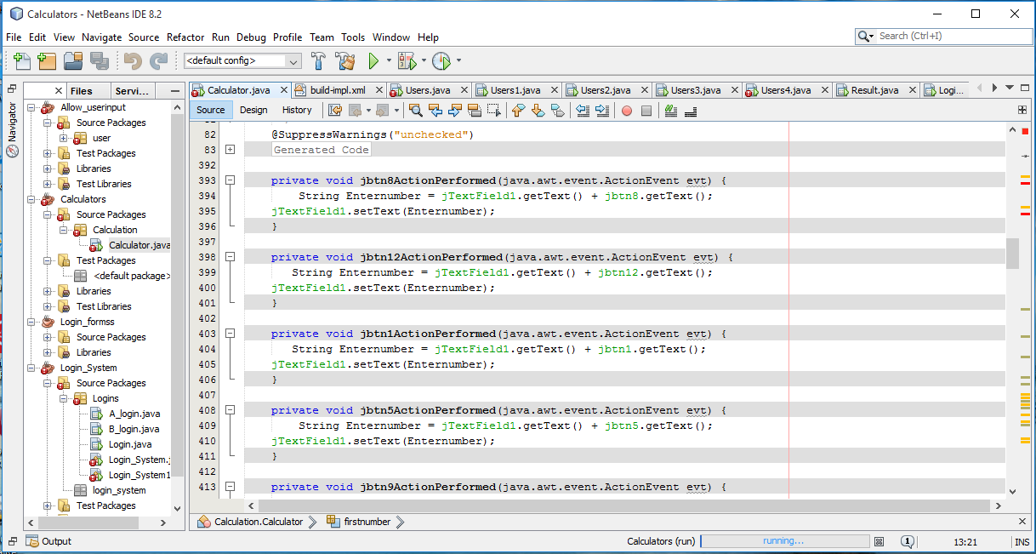

Complete calculator

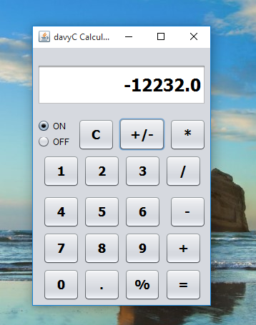

1. Development of complete login system work properly

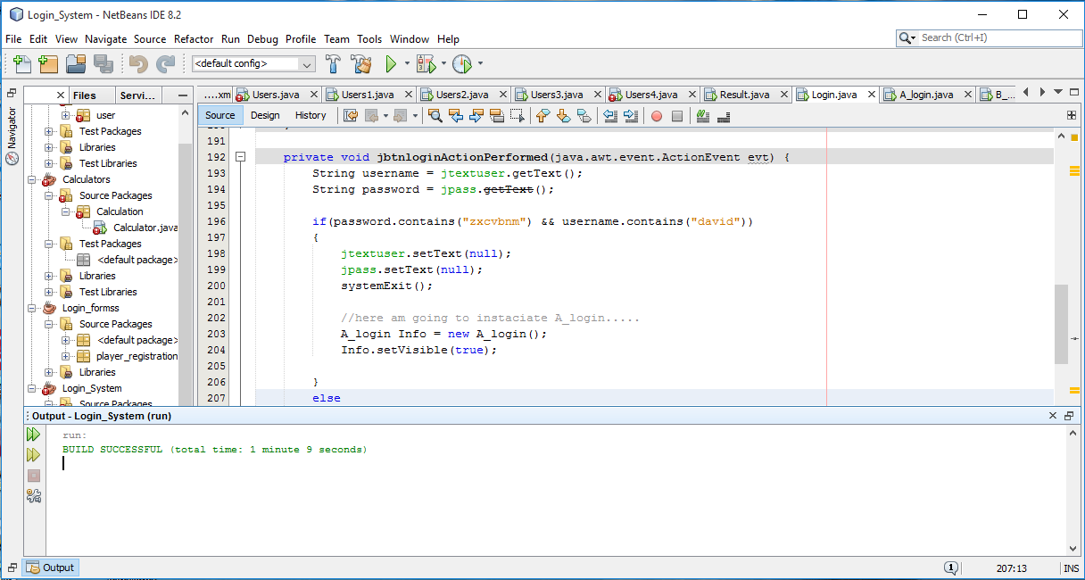

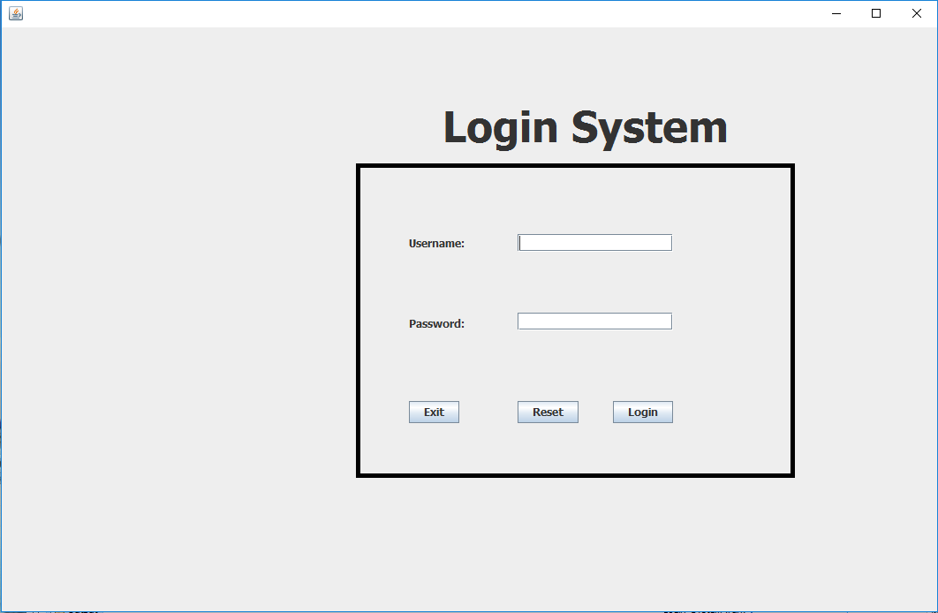

if username and password are incorrect

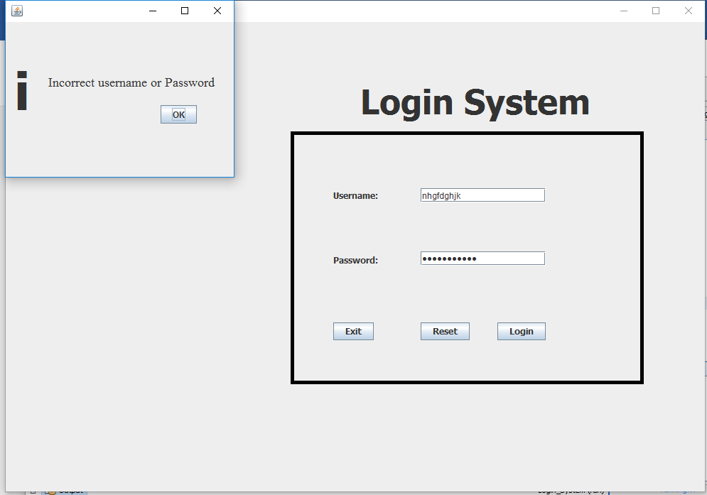

if username and password are correct, it gives you a message

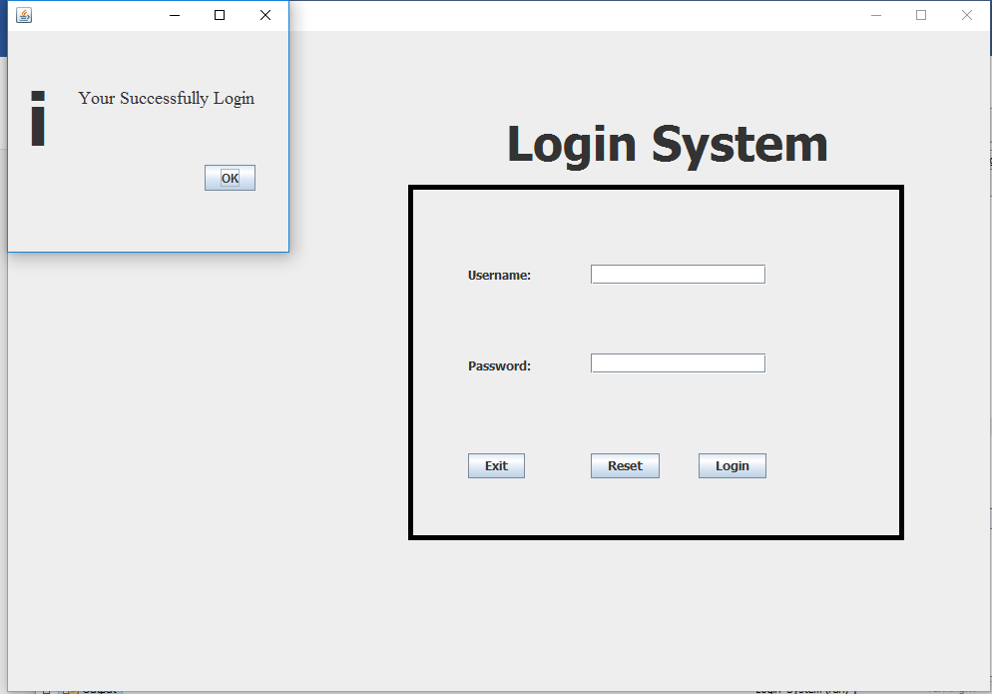

1. NetBeans IDE 8.2

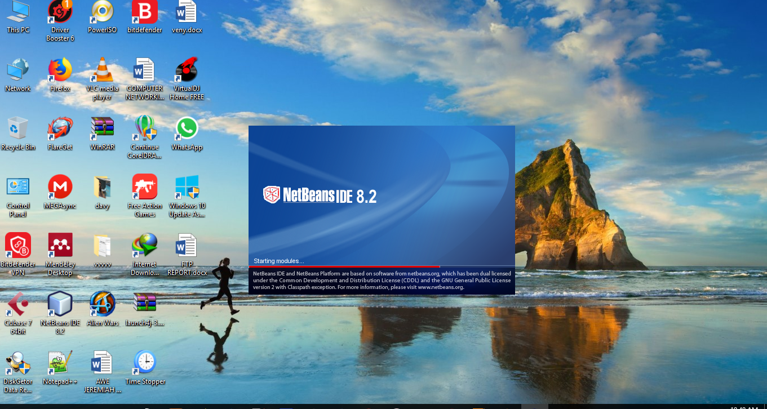

**TECHNICAL REPORT**

The opportunity to be contribute in my opinions for this field practical training is to make sure for every student to have knowledge because this is the stage for any student to more skills and to more competitive.

Also, another opinion is for every student to contribute and participate in tasks that are given by supervisor in order to accomplish goals.

Also, the time for field practical training should be fixed similar to the normal employee.